Assignment-07
Task-01: Fixing Syntax Errors
Prompt:
# I want to generate a python program to reviewing a basic function definition contains a syntax error.
# Provide a function add(a,b) with a missing colon.

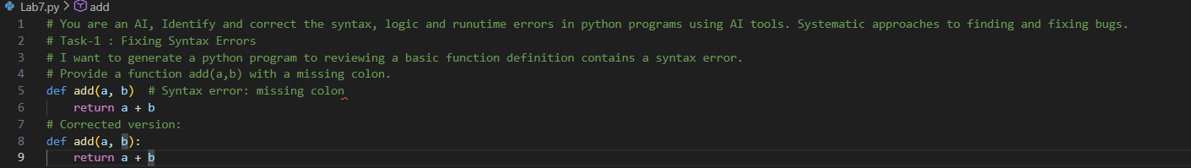
Task-02: Debugging Logic Errors in Loops
Prompt:
# You are debugging a loop that runs infinitely due to a logical mistake.
# Provide a loop with an incremental or decremental mistake that causes it to run indefinitely.

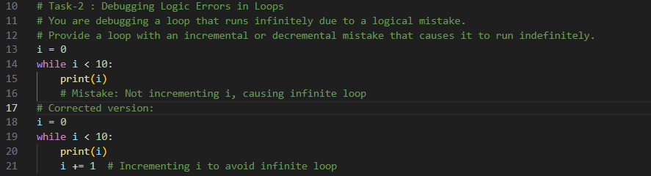
Task-03: Handling Runtime Errors (Division by Zero)
Prompt:
# Provide a python program that crashes during execution due to a division by zero error.
# Example usage that causes runtime error:
# result = divide(10, 0) # This will raise a ZeroDivisionError
# Corrected version with error handling:
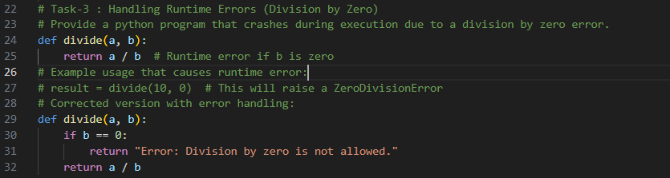
Task-04: Debugging Class Definition Errors.
Prompt:
# You are given a faulty class where the constructor is incorrectly defined.
# Provide a class with missing self parameter.
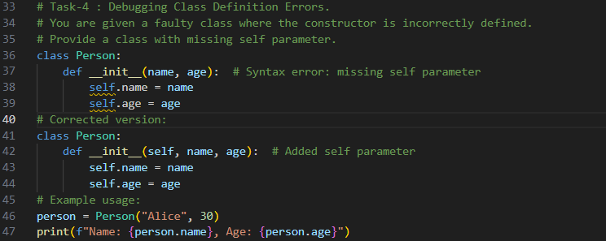
Task-05: Resolving Index Errors in Lists
Prompt:
# Provide a python program that crashes when accessing an invalid index in a list.
# Provide code that accesses an out-of-range list index
# Apply bounds checking or exception handling. Suggest safe access methods.

